System Call: As Kernel provides access to hardware space, System calls provides mechanism for user space to communicate with the Kernel Space.

**A system call is a mechanism using which a user program can request a service from the kernel for which it does not have the permission to perform. User programs typically do not have permission to perform operations like accessing I/O devices and Communicating other programs.**

AIM: TO create new folder:

* GUI makes it easy for that user to create new folder using right click methodology and new folder option. But its not that easy, who has made this so easy? OS
* CLI also does same task using MKDIR method.
* SCI - System Call Interface. As soon as we try to create new folder using CLI / GUI. User space will go to SCI and ask to take mkdir corresponding implementation.
* Then Kernel space runs that implementation written in C.
* All System calls are basically implemented in C.
* SCI is just interface to that C implementation.
* It is necessary as there is no other possible way for User space to go into Kernel space. They are placed separated.

Aim: To run helloworld.exe

* Whenever we run these EXE
  + Occurs system call to exec.
  + Then User Mode is switched to Kernel Mode.
    - Process Management works
    - Create process
  + KM to UM switch.
* How does User Mode to Kernel Mode switch happens.?
  + Exec Process
  + Software Interrupt occurs and then switch.

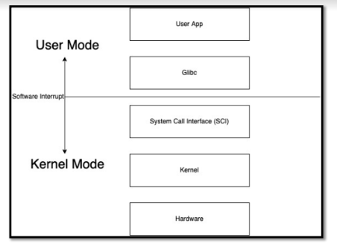

Study all the system calls from Doc on net

Try using in terminal